Pupil premium strategy statement – Uplands Junior L.E.A.D Academy
This statement details our school’s use of pupil premium (and recovery premium) funding to help improve the attainment of our disadvantaged pupils.
It outlines our pupil premium strategy, how we intend to spend the funding in this academic year and the outcomes for disadvantaged pupils last academic year.

School overview
Detail | Data
Number of pupils in school | 480
Proportion (%) of pupil premium eligible pupils | 145 pupils: 30%
Academic year/years that our current pupil premium strategy plan covers (3 year plans are recommended – you must still publish an updated statement each academic year) | 2023/24; 2024/25; 2025/26
Date this statement was published | October 2023
Date on which it will be reviewed | January 2024
Statement authorised by
Pupil premium lead | Luke Buckley  (Deputy Headteacher)
Governor / Trustee lead

Funding overview
Detail | Amount
Pupil premium funding allocation this academic year | £197,880
Recovery premium funding allocation this academic year  Recovery premium received in academic year 2023/24 cannot be carried forward beyond August 31, 2024. | £19,586
Pupil premium funding carried forward from previous years (enter £0 if not applicable) | £0
Total budget for this academic year  If your school is an academy in a trust that pools this funding, state the amount available to your school this academic year | £217,446

Part A: Pupil premium strategy plan

Statement of intent
At Uplands Junior L.E.A.D Academy, our ultimate objective for the pupil premium grant is to raise the educational attainment of disadvantaged pupils of all abilities so that they can achieve their potential, regardless of background or other barriers they may face. Trends in assessment information over the last 3 years show that there is an attainment gap between disadvantaged and non-disadvantaged pupils at Uplands. Our immediate priority is to reduce this attainment gap.
Pupil premium grant spending is linked to our Academy Improvement Plan to ensure that initiatives are embedded consistently through all year groups. While initiatives directly address the needs of disadvantaged pupils, many of them benefit all children in school as they are based on the delivery of high quality teaching and learning, enriching life experiences and social and emotional support.
In line with the Trust’s core principles (lead, empower, achieve an drive), the senior leadership team work closely with teaching staff to reflect on the changing needs of our disadvantaged pupils, empowering them to become confident learners who are able to achieve in English, maths and the wider curriculum.

Challenges
This details the key challenges to achievement that we have identified among our disadvantaged pupils.
Challenge number | Detail of challenge
1 | A high percentage of children speak English as an additional language. The 2023 census shows that 32 different first languages are spoken by our families.
2 | Pupil surveys have shown that children have narrow life experiences outside of school.
3 | Parental engagement with out-of-school learning and school initiatives (such as attendance at Parents’ Evening and lesson drop-ins) is low.
4 | Children demonstrate limited vocabulary. (Teacher assessment.)
5 | End of year data trends show that disadvantaged pupils’ attainment in reading, writing and maths is lower than the attainment of our non-disadvantaged children.
6 | Pupil surveys and teacher assessments show that children demonstrate difficulty in retaining knowledge across the curriculum.

Intended outcomes
This explains the outcomes we are aiming for by the end of our current strategy plan, and how we will measure whether they have been achieved.
Intended outcome | Success criteria
New-to-English children acquire the language quickly. | For each year group, a reduced percentage of children will be assessed as either A, B or C on the Bell Foundation’s EAL assessment framework.
Pupils have the same broad life experiences and are able to acquire the same cultural capital as non-disadvantaged pupils. | Pupils access the school’s broad educational visit program.  Pupils draw upon these experiences when accessing the curriculum.
Parental engagement with out-of-school learning and school initiatives is strengthened. | A greater number of parents attend information sessions, lesson drop-ins and Parents’ Evening meetings.  More home learning tasks are completed by pupils.
Children demonstrate broader vocabularies. | Children use a wider range of Tier 2 words in independent pieces of writing in all year groups.  More children achieve the expected standard in reading in all year groups.
The attainment gap between disadvantaged and non-disadvantaged pupils is closed. | Disadvantaged pupils at Uplands will achieve equal to or better than disadvantaged pupils nationally. The attainment gap between disadvantaged and non-disadvantaged pupils within the school in reading, writing and maths will be closed.
Children will retain more knowledge across the curriculum. | Teacher assessments and subject monitoring will show that pupils’ can recall and remember more knowledge across the wider curriculum.

Activity in this academic year
This details how we intend to spend our pupil premium (and recovery premium) funding this academic year to address the challenges listed above.

Teaching (for example, CPD, recruitment and retention)
Budgeted cost: £
Activity | Evidence that supports this approach | Challenge number(s) addressed

Targeted academic support (for example, tutoring, one-to-one support, structured interventions)
Budgeted cost: £151,840.86
Activity | Evidence that supports this approach | Challenge number(s) addressed
Support from teaching assistants (115,418.86)  One-to-one/ small group intervention, verbal feedback. | EEF – Making best use of teaching assistants.  Ensure TAs are fully prepared for their role. Handover time for teachers/teaching assistants is timetabled in.  Use TAs to help pupils develop independent learning skills. Ensure explicit connections are made between learning from everyday classroom teaching and structured interventions. TAs will be utilised to support children in using and understanding their knowledge organisers.  Use TAS to deliver high quality one-to-one and small group support using structured interventions. TAs in LKS2 will be trained in the use of rekenreks to support interventions in maths.  EEF evidence regarding the use of teaching assistants to deliver interventions shows an average gain of 4 months.  EEF evidence regarding feedback shows a gain of 6 months. Teaching assistants’ presence within classrooms raises frequency and quality of verbal feedback (+7 months) given to children by both teaching assistants and teachers. Disadvantaged pupils are prioritised for this. | 5 and 6
PE Leader (£12,541)  Physical activity; one-to-one/ small group intervention; verbal feedback. | EEF evidence regarding the benefits of physical activity shows an average gain of 1 month academic attainment. The PE leader also releases class teachers to support disadvantaged pupils in interventions or for verbal feedback on their learning (+7 months). | 5 and 6
Flash Academy learning platform. (£1440)  Teaching assistant interventions, parental engagement | Evidence is limited but children who have used this platform in school have reported that it has helped them to build their vocabulary. | 1 and 4
Accelerated Reader learning platform (£4309)  Teaching assistant interventions, parental engagement | Early trials from the EEF show an average gain of 3 months from pupils using accelerated reader. It promotes independent reading and reading for pleasure. | 5
Third Space learning (£18,000) for 28 children all year.  One-to-one tuition | EEF evidence regarding one to one tuition shows an average gain of 5 months. | 5

Wider strategies (for example, related to attendance, behaviour, wellbeing)
Budgeted cost: £65,737.14
Activity | Evidence that supports this approach | Challenge number(s) addressed
Pastoral care (£31,584)  Social and emotional learning  Fruit (£2300)  Milk (£7133.60) | EEF evidence regarding social and emotional intervention shows an average impact of +4 months. The support tends to be targeted and specific. Our Pastoral and Learning Mentor also works with children and families to support attendance. | 3 and 5
Lunchtime football club (£3000)  Physical activity, behaviour. | EEF evidence regarding the benefits of physical activity shows an average gain of 1 month academic attainment. This program also promotes positive behaviour (+4 months) and an enjoyment of school. | 5
Books to support home learning:  Revision guides for Year 6 (£360)  Books to support reading for pleasure (£1176)  Class novels (£2519)  Homework, parental engagement. | EEF evidence regarding homework shows a gain of 3 months. These resources are also part of the school’s attempt to raise parental engagement (+4 months). | 3, 5 and 6
School visits (£50 per pupil - £7350)  Year 6 residential for 20 people 2023/24 (£4244) | Pupil surveys show that children are gaining experiences through school visits but, at the moment, there is limited evidence on its impact on academic attainment. | 2
Rocksteady (£3833.04)  Leicestershire Music Hub – continuance of ukulele lessons (£784.50)  Peripatetic lessons 5 children (£1452)  Arts participation. | EEF evidence regarding participation in arts such as music shows an average improvement of 3 months. | 2 and 5

Total budgeted cost: £ 217,446

Part B: Review of the previous academic year
- Attendance for the year: PPG – 95.23% with PA – 10.67%; all children 95.37% with PA 8.51%. National attendance for the year: all children 92.6% PA – 21.8%
- All eligible children have fruit and milk daily and have trips funded.
- Rock Steady have matched the number of PPG children funded by school. 92% of Rock Steady are PPG children (22 out of 24). 43% of the choir are PPG children (13 out of 30)
- End of year teacher assessments:
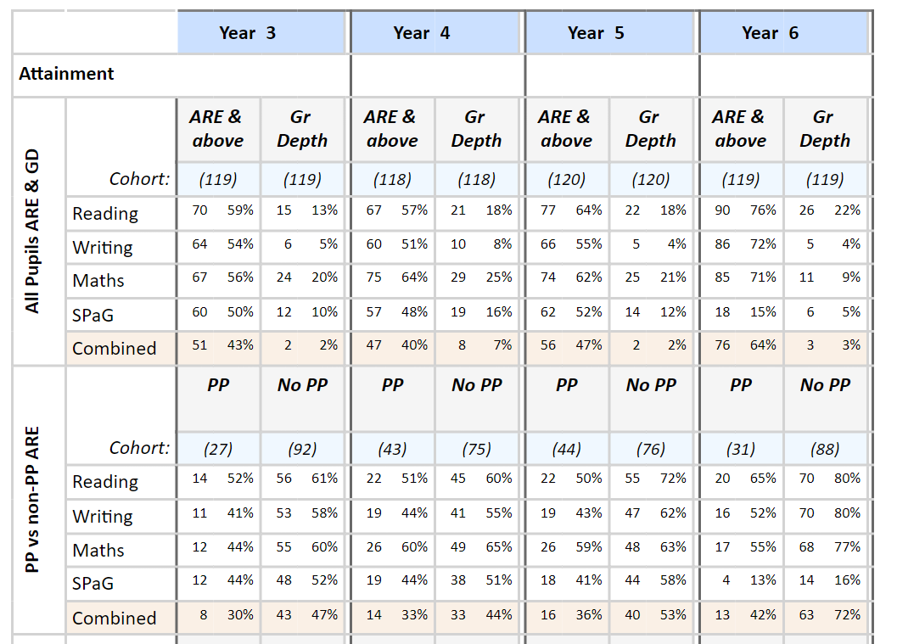
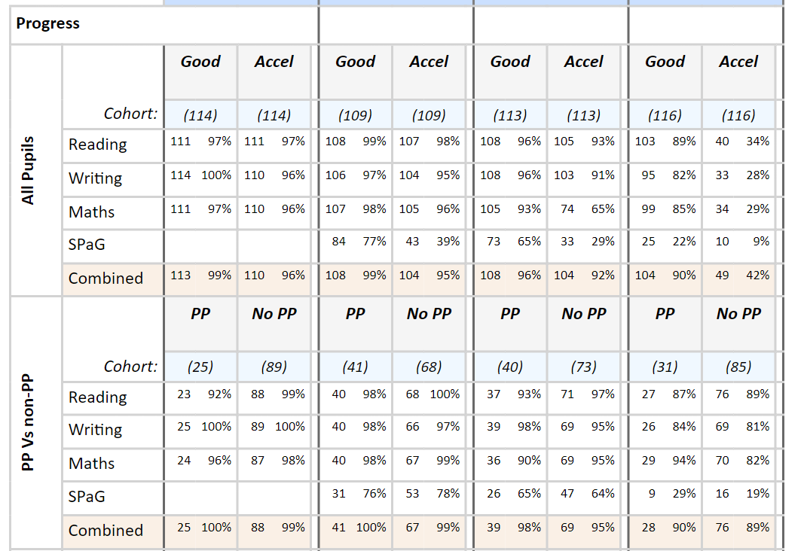
- Year 4 MTC – all children 87% scored 20 or above; 44% achieved 25/25; average score 22.43
PPG - 81% scored 20 or above; 37% achieved 25/25; average score 21.86
Last year’s national all children 27% scored 25/25; average score 19.8
- All bar 2 PPG children have now passed phonic screening test.
- Engagagement with after school clubs and competitions.

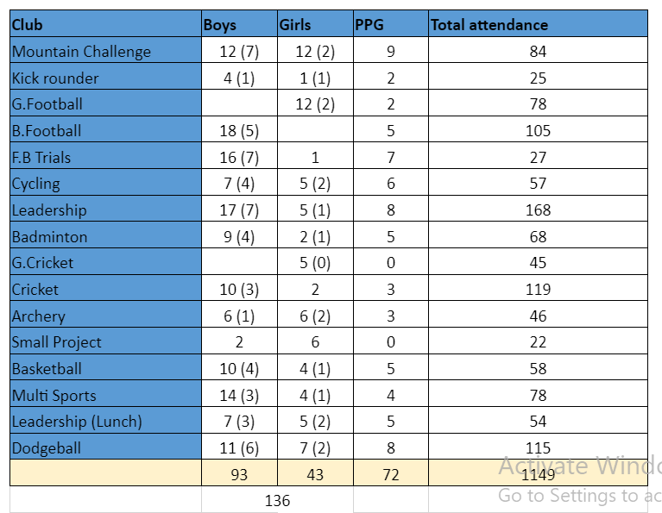
The improved attendance and reduction in persistent attendance means that attendance no longer should be a focus for pupil premium spending.

Outcomes for disadvantaged pupils

Externally provided programmes
Please include the names of any non-DfE programmes that you used your pupil premium (or recovery premium) to fund in the previous academic year.
Programme | Provider

Further information (optional)
Use this space to provide any further information about your pupil premium strategy. For example, about your strategy planning, implementation and evaluation, or other activity that you are delivering to support disadvantaged pupils, that is not dependent on pupil premium or recovery premium funding.

