L.E.A.D. ACADEMY TRUST
ATTENDANCE POLICY

Policy/Procedure management log

Document name | Attendance Policy
Author | Helen Tunney
Date approved | February 2023
Date issued | February 2023
Date of review | January 2024

Introduction

This statement sets out the legal framework, the definitions and our policy expectations.

The L.E.A.D. Academy Trust requires this policy to be implemented by all its member academies.

The policy makes the expectations for attendance management explicit in order to ensure consistency of practice across the network of academies. The L.E.A.D. Academy Trust’s aim is for all of its academies to be calm, orderly, safe, and supportive environments where all pupils want to be in school and are keen and ready to learn.

The L.E.A.D. Academy Trust defines the policy expectation, but the responsibility for implementation of the policy rests with the Headteacher of each academy.

Cross Reference: Safeguarding Policy, Behaviour Policy, SEND policy

Legislative Framework

This policy meets the requirements of the working together to improve school attendance from the Department for Education 2022 (DfE), and refers to the DfE’s statutory guidance on school attendance parental responsibility measures. These documents are drawn from the following legislation setting out the legal powers and duties that govern school attendance:

Part 6 of The Education Act 1996
Part 3 of The Education Act 2002
Part 7 of The Education and Inspections Act 2006
The Education (Pupil Registration) (England) Regulations 2006 (and 2010, 2011, 2013, 2016 amendments)
The Education (Penalty Notices) (England) (Amendment) Regulations 2007 (and 2013 amendments)

Procedures for attendance management implemented by individual academies will be operated in a positive way, reflecting the high expectations of all within the academy community.

All staff are responsible for promoting and establishing good attendance in Trust academies. It is important that all staff are consistent and proactive in rewarding good attendance, and in dealing with poor attendance.

Trust Expectations of Academies

To manage and improve attendance effectively, the Trust expects every academy to:
- Have a clear attendance policy which all staff, pupils and parents understand. The policy must include:

- Attendance and punctuality expectations of pupils and parents, including:
  - start and close of the day
  - register closing times
  - processes for requesting leaves of absence
  - processes for informing the school of the reason for an unexpected absence.

- The name and contact details of the senior leader responsible for the strategic approach to attendance.
- Information and contact details of staff who pupils and parents should contact about attendance on a day to day basis.
- Information regarding day to day processes for managing attendance, for example first day calling and processes to follow up on unexplained absence.
- How the academy is promoting and incentivising good attendance.
- The strategy for using data to target attendance improvement efforts to the pupils or pupil cohorts who need it most.
- The strategy for reducing persistent and severe absence, including how access to wider support services will be provided to remove the barriers to attendance and when support will be formalised in conjunction with the local authority.
- The point at which Fixed Penalty Notices for absence and other sanctions will be sought if support is not appropriate (e.g. for an unauthorised holiday in term time), not successful, or not engaged with.

- Develop and maintain a whole academy culture that promotes the benefits of high attendance.
- Accurately complete admission and attendance registers, and have effective day to day processes in place to follow-up absence.
- Regularly monitor and analyse attendance and absence data to identify pupils or cohorts that require support with their attendance and put effective strategies in place.
- Build strong relationships with families, listen to and understand barriers to attendance and work with families to remove them.
- Share information and work collaboratively with other schools and academies in the area, local authorities, and other partners when absence is at risk of becoming persistent or severe.

Improving attendance requires constant focus, and effective whole academy approaches require regular ongoing support, guidance, and challenge. The Trust expects each Academy Governing Body (AGB) to:
  - Recognise the importance of attendance and promote it.
  - Ensure leaders fulfil expectations and statutory duties.
  - Regularly review attendance data, discuss, and challenge trends, and help academy leaders focus improvement efforts on the individual pupils or cohorts who need it most.
  - Ensure staff receive adequate training on attendance.

Day to Day Processes

Alongside accurate recording of attendance and absence, the Trust expects each academy to have robust day to day processes to track and follow up absence and poor punctuality and to develop processes that meet the needs of their pupils and contexts. As a minimum, each academy must:
- Proactively manage lateness and set out the length of time the register will be open, after which a pupil will be marked as absent. This should be the same for every session, and depending on the structure of the school day, not longer than either 30 minutes after the session begins, or the length of the form time or first lesson in which registration takes place.
- Identify any absences that are not explained for each session and contact parents (and where appropriate foster carers and/or social workers) to understand why and when the pupil will return. Where absence is recorded as unexplained in the attendance register, the correct code should be inputted as soon as the reason is ascertained, but no later than 5 working days after the session.
- Where reasonably possible, hold more than one emergency contact number for each pupil.
- Regularly inform parents about their child’s attendance and absence levels.
- Hold regular meetings with the parents of pupils whom the academy (and/or local authority) considers to be vulnerable or are persistently or severely absent to discuss attendance and engagement at school.
- Identify pupils who need support from wider partners as quickly as possible and make the necessary referrals.
- Make the necessary statutory data returns.
- Support pupils on return following a lengthy or unavoidable period of absence to build confidence and bridge gaps.

Each academy, in order to instil good attendance, should therefore:

- Work closely with their Local Authority School Attendance Support Team.
- Organise regular targeted meetings with families.
- Take a multi-disciplinary approach with the School Attendance Team to overcome barriers.
- Undertake legal intervention, where all voluntary support options are unsuccessful (Attendance Prosecution).
- Use parenting contracts as a formal written agreement with the academy.
- Implement an Education Supervision Order (ESO) where a formal parenting contract has been unsuccessful. An ESO is a useful alternative to provide formal legal intervention without criminal prosecution.
- Initiate fixed penalty notices by working with the Local Authority.
- Make use of Parenting Orders following non-attendance alongside a fine and or a community order. These can be imposed by the Court.

Equality Statement
The L.E.A.D. Academy Trust is committed to applying the equality duty in all academies across all phases. It is the responsibility of all staff, leaders, trustees and governors to have due regard to the need to eliminate unlawful discrimination, to advance equality of opportunity, and to foster good relations between people.

Safeguarding

L.E.A.D. Academy Trust recognises that attendance may be an indicator that a pupil is in need of help or protection. As a result, we expect each academy to consider whether a pupil’s attendance may be linked to them suffering, or being likely to suffer, significant harm.
Where this may be the case, the academy is expected to follow our child protection and safeguarding policy, and consider whether pastoral support, an early help intervention or a referral to children’s social care is appropriate.

Monitoring, Evaluation and Review

In order to determine the effectiveness of a policy, the Trust will monitor and evaluate its impact. This will be achieved by:

- Regular analysis of data.
- The AGB reviewing progress made and the effectiveness of the policy on an annual basis.
- The Trust Board scrutinising the attendance data and any issues reported in the Quality Assurance (QA) visits made by Directors of Schools.

Uplands Junior L.E.A.D. Academy

Attendance Policy

Policy Information

Document name | Attendance Policy
Date approved | Dec 2023
Date issued | Feb 2023
Date of review | Sept 2023
Approved by | Reviewed by LC Sept 2023

1. Aims
At Uplands Junior L.E.A.D. Academy we are committed to meeting our obligation with regards to school attendance through our culture and ethos that values good attendance, including by:
- Promoting good attendance
- Reducing absence, including persistent and severe absence
- Ensuring every pupil has access to the full-time education to which they are entitled
- Acting early to address patterns of absence
- Building strong relationships with families to ensure pupils have the support in place to attend
- Promoting and supporting punctuality in attending lessons

2. Legislation and Guidance
This policy meets the requirements of the working together to improve school attendance from the Department for Education 2022 (DfE) updated September 2023, and refers to the DfE’s statutory guidance on school attendance parental responsibility measures. These documents are drawn from the following legislation setting out the legal powers and duties that govern school attendance:

Part 6 of The Education Act 1996
Part 3 of The Education Act 2002
Part 7 of The Education and Inspections Act 2006
The Education (Pupil Registration) (England) Regulations 2006 (and 2010, 2011, 2013, 2016 amendments)
The Education (Penalty Notices) (England) (Amendment) Regulations 2007 ( and 2013 amendments)

3. Roles and Responsibilities
3.1 Academy Trustees
Trustees are responsible for:

- Ensuring that there is a Trust wide strategy to improve attendance

Academy Governing Bodies (AGBs) are responsible for:

- Promoting the importance of good attendance across the academy’s policies and through its ethos
- Making sure academy leaders fulfil expectations and statutory duties
- Regularly reviewing and challenging attendance data
- Making sure staff receive adequate training on attendance
- Holding the Headteacher to account for the implementation of this policy

3.2 The Headteacher
The Headteacher is responsible for:

- Implementation of this policy at the academy
- Monitoring absence data and reporting it to governors
- Supporting staff with monitoring the attendance of individual pupils
- Monitoring the impact of any implemented attendance strategies
- Authorising the Local Authority issuing of fixed-penalty notices where necessary

3.3 The Designated Senior Leader Responsible for Attendance
The designated senior leader is responsible for:

- Leading attendance across the academy
- Offering a clear vision for attendance improvement
- Evaluating and monitoring expectations and processes
- Having an oversight of data analysis
- Devising specific strategies to address areas of poor attendance identified through data
- Arranging calls and meetings with parents to discuss attendance issues
- Delivering targeted intervention and support to pupils and families

The designated senior leader responsible for attendance is Mrs Carlisle and can be contacted via 0116 253 8407 or by email lcarlisle@uplandsacademy.co.uk

3.4 The Attendance Officer
The academy attendance officer is responsible for:

- Monitoring and analysing attendance data (see section 7)
- Benchmarking attendance data to identify areas of focus for improvement
- Providing regular attendance reports to academy staff and reporting concerns about attendance to the designated senior leader responsible for attendance and the Headteacher
- Working with the School Attendance Support team to tackle persistent absence

The attendance officer is Mrs Carlisle and can be contacted via 0116 253 8407 or by email lcarlisle@uplandsacademy.co.uk

3.5 Class Teachers

Class teachers are responsible for recording attendance on a daily basis, using the correct codes, and submitting this information to the office at 8.45 and 1 pm daily.

3.6 Academy Admin/Office Staff
Academy staff will:
- Record all absence details received on a day-to-day basis and log it on the academy MIS system
- Transfer calls from parents to the Mrs Carlisle or Mrs R Patel in order to provide them with more detailed support on attendance

3.7 Parents/Carers
Parents/carers are expected to:

- Make sure their child attends every day on time
- Call the academy to report their child’s absence before 8.45 on the day of the absence and each subsequent day of absence, and advise when their child is expected to return
- Provide the academy with more than 1 emergency contact number for their child and update accordingly
- Ensure that, where possible, appointments for their child are made outside of the academy day

3.8 Pupils
Pupils are expected to:

- Attend every day on time

3.9 The Local Authority
The Local Authority is legally obliged to:

- Provide a strategic approach to improving attendance and ensure that it is a key focus of all frontline services
- Provide access to the School Support Team
- Enable opportunities to share effective practice
- Work with academies to issue legal interventions

4. Recording Attendance
4.1 Attendance Register
At Uplands Junior L.E.A.D. Academy, we keep an attendance register of all pupils on the academy roll.
We will take our attendance register at the start of the first session of each day and once during the second session. It will mark whether every pupil is:
- Present
- Attending an approved off-site educational activity
- Absent
- Unable to attend due to exceptional circumstances

Any amendment to the attendance register will include:

- The original entry
- The amended entry
- The reason for the amendment
- The date on which the amendment was made
- The name and position of the person who made the amendment

DfE attendance codes can be found in appendix 1.
We will also record:
- Whether the absence is authorised or not
- The nature of the activity if a pupil is attending an approved educational activity
- The nature of circumstances where a pupil is unable to attend due to exceptional circumstances

We will keep every entry on the attendance register for 3 years after the date on which the entry was made.

The school day at Uplands Junior L.E.A.D. Academy starts at 8.30. Pupils must arrive by 8.45 every day.
The register for the first session will be taken at 8.45 and will be kept open until 9.00. The register for the second session will be taken at 13.00 and will be kept open until 13.05.
4.2 Unplanned Absence
The pupil’s parent/carer must notify the academy of the reason for the absence on the first day of an unplanned absence by 8.45 or as soon as practically possible by calling the Academy on 0116 253 8407.
Parents can also send an email to office@uplandsacademy.co.uk or send a message through the Gateway app.
We will mark absence due to illness as authorised unless Uplands Junior L.E.A.D. Academy has a genuine concern about the authenticity of the illness. If the authenticity of the illness is in doubt, Uplands Junior L.E.A.D. Academy may ask the pupil’s parent/carer to provide medical evidence, such as a doctor’s note, prescription, appointment card or other appropriate form of evidence. We will not ask for medical evidence unnecessarily.

If the academy is not satisfied about the authenticity of the illness, the absence will be recorded as unauthorised and parents/carers will be notified of this in advance.

4.3 Planned Absence
Attending a medical or dental appointment will be counted as authorised as long as the pupil’s parent/carer notifies the academy in advance of the appointment. Evidence of the appointment should be shown at the school office.
However, we encourage parents/carers to make medical and dental appointments out of school hours where possible. Where this is not possible, the pupil should be out of the academy for the minimum amount of time necessary.
The pupil’s parent/carer must also apply for any other type of term-time absence as far in advance as possible of the date or dates of the requested absence.

4.4 Lateness and Punctuality
A pupil who arrives late:
- Before the register has closed, will be marked as late, using the appropriate code ‘L’
- After the register has closed will be marked as absent, using the appropriate code ‘U’ which signifies that the pupil arrived after the official closing of the register and denotes an unauthorised absence.

4.5 Following up Unexplained Absence
Where any pupil we expect to attend does not attend, or stops attending without reason, the academy will:

- Call the pupil’s parent/carer on the morning of the first day of unexplained absence to ascertain the reason. If the academy cannot reach any of the pupil’s emergency contacts, the academy may send an email/contact the police or social care to ascertain the whereabouts of the child.
- Identify whether the absence is approved or not
- Identify the correct absence code to use and input it as soon as the reason for absence is ascertained – this will be no later than 5 working days after the session
- Call the parent/carer on each day that the absence continues without explanation to ensure proper safeguarding action is taken where necessary. If absence continues, the academy will consider involving the School Attendance Support Team and or other frontline services.

4.6 Reporting to Parents/Carers
The academy will regularly inform parents about their child’s attendance and absence levels termly.

5. Authorised and Unauthorised Absence
5.1 Approval for Term-time Absence
Only exceptional circumstances warrant a leave of absence. Uplands Junior L.E.A.D. Academy will consider each application individually taking into account the specific facts and circumstances and relevant background context behind the request. If a leave of absence is granted, it is for the Headteacher to determine the length of the time the pupil can be away from school. As Headteachers should only grant leaves of absence in exceptional circumstances it is unlikely a leave of absence will be granted for the purposes of a family holiday.
Any request should be submitted as soon as it is anticipated and, where possible, at 4 weeks before the absence, and in accordance with any leave of absence request form (Appendix 3), accessible via the school office or the website. The Headteacher may require evidence to support any request for leave of absence such as flight tickets and will meet with the parents to discuss the request.
Valid reasons for authorised absence may include:
- Illness and medical/dental appointments (see sections 4.2 and 4.3 for more detail)
- Religious observance – where the day is exclusively set apart for religious observance by the religious body to which the pupil’s parents belong. If necessary, the academy will seek advice from the parents’ religious body to confirm whether the day is set apart
- Traveller pupils travelling for occupational purposes – this covers Roma, English and Welsh gypsies, Irish and Scottish travellers, showmen (fairground people) and circus people, bargees (occupational boat dwellers) and new travellers. Absence may be authorised only when a traveller family is known to be travelling for occupational purposes and has agreed this with the academy, but it is not known whether the pupil is attending educational provision

5.2 Pupils with Medical Conditions or Special Educational Needs and Disabilities
In line with Section 19 of the Education Act 1996 the Local Authority (LA) have a duty to: “make arrangements for the provision of suitable education at school or otherwise than at school for those children of compulsory school age who, by reason of illness, or otherwise, may not for any period receive suitable education unless such arrangements are made for them.”
This applies to children and young people:
- who are of statutory school age and who
- are permanently resident in the local authority and
- who are not in school for 15 days or more, whether consecutive or cumulative due to ill health and
- where the health need and necessity for absence has been validated as necessary by a medical doctor
- will not receive a suitable full-time education unless the local authority makes arrangements for this

Health problems include: disabilities, physical illnesses, injuries and clinically defined mental health problems. Suitable medical evidence will be required, including details of the health problem, how long the condition is expected to last, the likely outcome, and a treatment plan. This must be provided by a suitable medical professional, normally a hospital consultant. However, where specific medical evidence is not available quickly, the local authority will liaise with other medical professionals (e.g. the child's GP), so that provision of education is not delayed.
5.3 Children Missing Education (CME)
The academy recognises that early intervention is necessary to identify the existence of any underlying safeguarding risk, and to help prevent the risks of a child going missing in education. The academy will:

- Follow absence procedures
- Make a referral to CME if information is obtained that the family have moved out of area, with no forwarding school/academy
- Make a referral to CME if a pupil has not returned after 10 days and there has been no contact with the family, despite efforts made by the academy
- Work closely with the Children Missing Education (CME) Officer to identify a pupil’s current whereabouts/destination
- Agree with CME an appropriate time and category to remove the child from the academy roll. This includes those children and young people who are expected to move swiftly into appropriate provision; this is in line with The Education (Pupil Registration) (England) (Amendment) Regulations 2016
- Contact the Local Authority via CME after 20 school days of absence, to discuss whether to remove a pupil from the academy roll. The final decision about removal from the academy roll remains with the Headteacher.
- The academy will create a ‘lost pupil’ record on the national Lost Pupil’s Database School to School (s2s) to assist future schools and Children Missing from Education Officers to identify and locate children

5.4 Legal Sanctions
The academy can refer parents to the local authority where they do not ensure that children attend school. Parents can be fined for the unauthorised absence of their child from school, where the child is of compulsory school age.
If issued with a fine, via a fixed penalty notice (FPN), each parent must pay £60 within 21 days or £120 within 28 days. The payment must be made directly to the local authority.
The decision on whether or not to issue a penalty notice may take into account:
- The number of unauthorised absences occurring within a rolling academic year
- One-off instances of irregular attendance, such as holidays taken in term time without permission
- Where an excluded pupil is found in a public place during school hours without a justifiable reason

If the payment has not been made after 28 days, the local authority can decide whether to prosecute.

6. Strategies for Promoting Attendance
- Meet and greet on the school gate each morning.
- Celebration of good attendance – attendance boards, rewards, certificates, termly medals, weekly comment on newsletter.

7. Attendance Monitoring

7.1 Monitoring Attendance
Uplands Junior L.E.A.D. Academy will:
- Monitor attendance and absence data trends on a half-termly, termly and yearly basis in relation to whole cohorts and distinct pupil groups
- Monitor individual pupil attendance, absence and punctuality on a daily and weekly basis
- Identify whether or not there are particular groups of children whose absences may be a cause for concern
- Pupil-level absence data will be collected each term and published at national and local authority level through the DfE's school absence national statistics releases. The underlying academy-level absence data is published alongside the national statistics. The academy will compare attendance data to the national average, and share this with the governing board.

7.2 Analysing Attendance
Uplands Junior L.E.A.D. Academy will:

- Analyse attendance and absence data regularly to identify pupils or cohorts that need additional support with their attendance, and use this analysis to provide targeted support to these pupils and their families
- Look at historic and emerging patterns of attendance and absence, and then develop strategies to address these patterns

7.3 Using Data to Improve Attendance
Uplands Junior L.E.A.D. Academy will:
- Provide regular attendance reports to class teachers and other academy leaders, to facilitate discussions with pupils and families
- Use data to monitor and evaluate the impact of any interventions put in place in order to modify them and inform future strategies

7.4 Reducing Persistent and Severe Absence
Persistent absence is where a pupil misses 10% or more of school, and severe absence is where a pupil misses 50% or more of school.

The academy will:
- Use attendance data to find patterns and trends of persistent and severe absence
- Hold regular meetings with the parents of pupils who the academy (and/or local authority) considers to be vulnerable, or are persistently or severely absent, to discuss attendance and engagement
- Issue letters to parents to make them aware of poor attendance and the need to improve.
- Provide access to wider support services to remove the barriers to attendance
- Use all available legal means at the academies disposal to challenge situations where there is severe and persistent absence

8. Policy Review
This policy will be reviewed as guidance from the local authority or DfE is updated, and as a minimum annually by Mrs Carlisle. At every review, the policy will be approved by the AGB.

9. Links with Other Policies
This policy links to the following policies:
- Child protection and safeguarding policy
- Behaviour policy
- Equality policy

Appendix 1: attendance codes
The following codes are taken from the DfE’s guidance on school attendance.

Code | Definition | Scenario
/ | Present (am) | Pupil is present at morning registration
\ | Present (pm) | Pupil is present at afternoon registration
L | Late arrival | Pupil arrives late before register has closed
B | Off-site educational activity | Pupil is at a supervised off-site educational activity approved by the school
D | Dual registered | Pupil is attending a session at another setting where they are also registered
J | Interview | Pupil has an interview with a prospective employer/educational establishment
P | Sporting activity | Pupil is participating in a supervised sporting activity approved by the school
V | Educational trip or visit | Pupil is on an educational visit/trip organised, or approved, by the school
W | Work experience | Pupil is on a work experience placement

Code | Definition | Scenario
Authorised absence
C | Authorised leave of absence | Pupil has been granted a leave of absence due to exceptional circumstances
E | Excluded | Pupil has been excluded but no alternative provision has been made
H | Authorised holiday | Pupil has been allowed to go on holiday due to exceptional circumstances
I | Illness | School has been notified that a pupil will be absent due to illness
M | Medical/dental appointment | Pupil is at a medical or dental appointment
R | Religious observance | Pupil is taking part in a day of religious observance
S | Study leave | Year 11 pupil is on study leave during their public examinations
T | Gypsy, Roma and traveller absence | Pupil from a traveller community is travelling, as agreed with the school
Unauthorised absence
G | Unauthorised holiday | Pupil is on a holiday that was not approved by the school
N | Reason not provided | Pupil is absent for an unknown reason (this code should be amended when the reason emerges, or replaced with code O if no reason for absence has been provided after a reasonable amount of time)
O | Unauthorised absence | School is not satisfied with reason for pupil's absence
U | Arrival after registration | Pupil arrived at school after the register closed

Code | Definition | Scenario
X | Not required to be in school | Pupil of non-compulsory school age is not required to attend
Y | Unable to attend due to exceptional circumstances | School site is closed, there is disruption to travel as a result of a local/national emergency, or pupil is in custody
Z | Pupil not on admission register | Register set up but pupil has not yet joined the school
# | Planned school closure | Whole or partial school closure due to half-term/bank holiday/INSET day

Appendix 2:
Flow chart of promoting good attendance
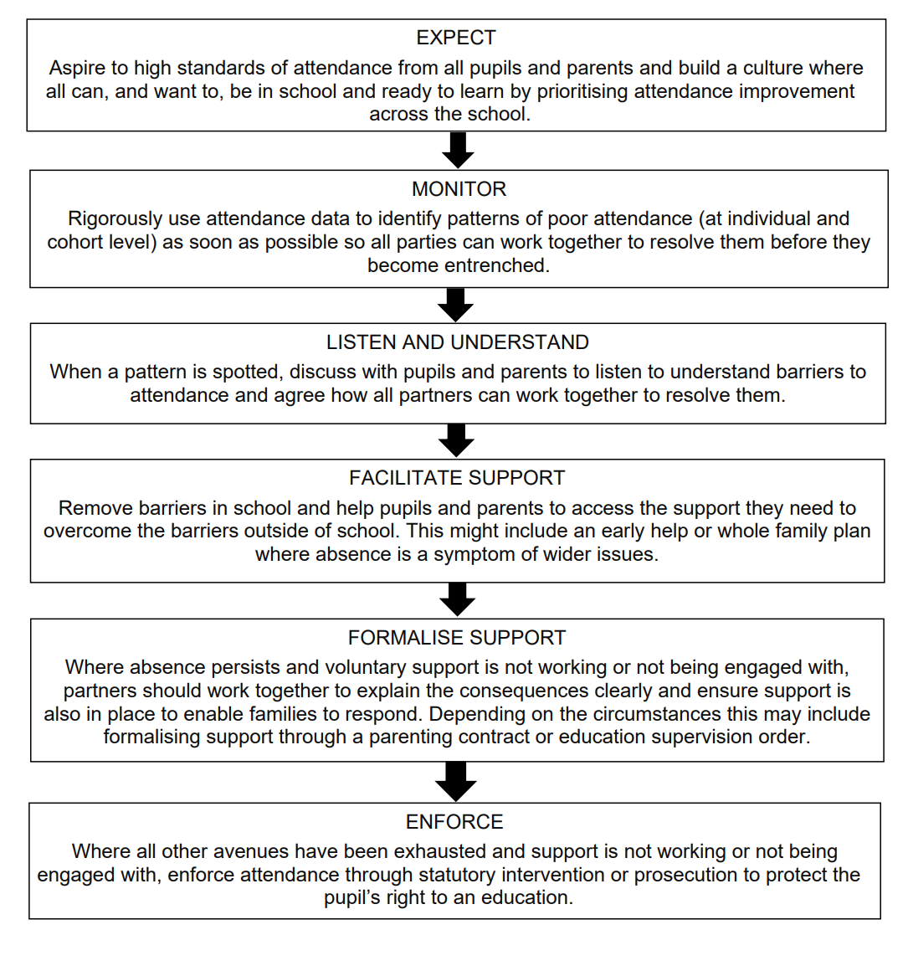

Appendix 3:

UPLANDS JUNIOR L.E.A.D. ACADEMY LEAVE OF ABSENCE REQUEST (Model)

