Pupil Premium Strategy for 2021-22
Based upon the evaluation of the outcomes from the previous academic year, research of projects for raising attainment and our own knowledge of what has worked well in our own academy the following strategy has been agreed:
- Summary information for 2021-22
Academy | Uplands Junior LEAD Academy
Pupil Premium Leader | Sonya Raybould
Academic Year | 2021-2022 | Total PP budget | £137,190 | Date of most recent PP Review | 31/08/2021
Total number of pupils | 476 | Number of pupils eligible for PP | 46 current children (DfE list) plus 96 additional pupils currently FSM | Date for next internal review of this strategy | End of term 2 2022

- Barriers to future attainment (for pupils eligible for PP including high ability)
In-school barriers (issues to be addressed in school, such as weak teaching, low attainment of whole cohort, etc) | External barriers (issues which also require action outside school, such as low attendance rates, high new EAL, mobility, social care and safeguarding)
 | Narrow life experiences outside of school.
Knowledge of vocabulary and language | High percentage of children new to English, 23 languages spoken by children. Many parents are not fluent in English.
Subject knowledge/general knowledge to achieve and make progress. | Time pupils have to complete home learning tasks due to religious commitments
Term time holidays and attendance.
Broader life experiences limited. | Pupils have limited access to the internet

- Implementation and/or Impact of the curriculum – separate for each year group as each cohort has its own profile and needs. This could include training to improve the implementation of the curriculum, strategies to engage pupils in specific curriculum areas or interventions to raise attainment in core subjects.
What do we want to achieve? |  |  | How? | What is the rationale for this chosen strategy? | How will it be monitored | Cost?
Year Group | What do you want to achieve and how they will be measured | Success criteria | How will the intervention or provision be delivered? | Refer to research from EEF or other research to justify the choice of strategy. |  | Provide simple breakdown of proportionate or full costs.
All year groups | Raise attendance and lower persisitant absence. | Aspirational target of 96% attendance and near national persistent absence.  PPG attendance to be within 1% of all attendance. | - Amended attendance policy Jan 2022.  - Summary of changes communicated to parents.  - EWO fortnightly  - Office staff chase every absence, every day.  - Long term communications in different languages to parents about importance of school attendance.  - Rewards at individual and class level.  - Consistency of approach for term time holidays. | 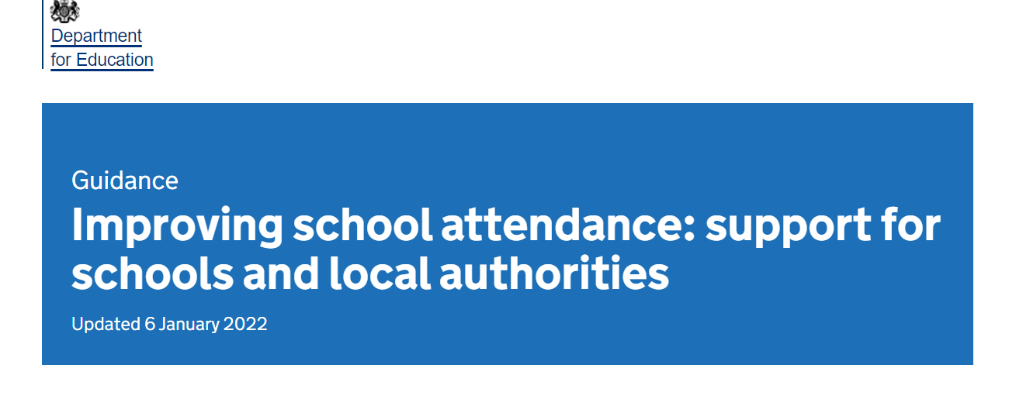 | Daily on individaul level, weekly to classes.  Working with EWO | £5871 per year.
All year groups | Raise acquisition of English – new to English children and widen vocabulary of all children | Reducing numbers of children that require support for EAL as the children progress through school. | Daily phonics and reading for those children that are identified as requiring support to read.  Flash Academy – supports learning of English language. EAL leads to monitor home use and analysis of termly assessments and report to SLT.  Intervention by TA 8.30-9am daily.  EAl leads to deliver workshop to parents.  All staff to prioritise the acquisition and understanding of vocabulary through every lesson. | A systematic review of intervention research examining English language and literacy development in children with English as an Additional Language (EAL) (d2tic4wvo1iusb.cloudfront.net) | Assessment data.  Pupil voice | Flash Academy
All year groups | Children increase knowledge of the world around them through wider experiences. | All PPG children and parents are made aware of the offer. | All PPG children will receive:  - Free milk  - Free school trips and residential visits  - Free musical instrument tuition for 1 term per academic year.  - 3 free books per academic year.  - Free swimming for Y5  - Free music lessons with Rock Steady  - Access a school uniform voucher from School Direct  - A piece of free fruit at breaktime. | Equal access to non disadvantage children at Uplands Junior. | Data  Pupil and parent voice.  No child will be disadvantaged in terms of opportunities. | Milk – 21p per pupil per day= £1872  School trips approx - £50 per pupil per year Y3-Y5= £2300  Y6 residential(2022-23)  Musical intrument tuition approx £100- £4600  Books - £20 per child= £920  Rock Steady £7 per week per child -£200  Swimming £2 per week for transport for £18 weeks for Y5 = £720  Uniform -£30 per year in vouchers = £1380  Fruit £50 per week total =£1950  Total= £19,813
All year groups | To ensure that PPG children make progress and achieve across the curriculum. | No child is disadvantaged. | Support from Teaching Assistants. | EEF | Data  Pupil voice, participation and engagement. | £79, 106

Whole School Initiatives/the wider curriculum | How? | What is the rationale for this chosen strategy? | How will it be monitored? | Cost?
Accelerated Reader | On-line tool to monitor and encourage pupils to read more books. | Research for the EEF shows that this initiative raises attainment by +5 months for eligible pupils and +3 months for all pupils. | Reading Leader to monitor reading statistics from on-line information. Report to SLT. | Proportionate cost plus leadership time cost  £13,785.5
Provide pastoral care for pupils. | Daily meet and greet for parents and carers. Home visits as required.  Pastoral support within the school day | +4  SEL interventions on average provide four months’ progress. The pastoral manager will provide a range of support including art therapy, liaising with parents and carers over SEL issues. | Attendance of vulnerable pupils in receipt of pupil premium | £15,815.50
Provide EAL support Flash Academy | Daily intervention with HLTA | +4  Research shows that digital technology increases progress by an average of four months +4. This progress measure will also impact on classroom based outcomes as children will be able to access the wider curriculum. | Data collected by EAL lead | £1400 – support from HLTA
Wider curriculum support | Pupils will be selected to participate in additional opportunities, such as rock steady, boxing, skipping. | +2  Extended arts or sports participation impacts positively on academic achievement but impact is low. Pupils have limited opportunities to engage in extra-curricular activities due to commitments to attending madrassa after school. | PE lead will include PPG and recognise talent and signpost to clubs.
 |  | Total |  | £137, 190

Date: 13.10.21
Pupil Premium Leader: Sonya Raybould

Review and Impact August 2022
Objective | Impact
To raise attendance and lower persistent absence | All children  School attendance 94.77% attendance for the academic year 2021-22  PA 11.2%  For PPG children  School attendance 94.65% attendance for the academic year 2021-22  PA 10.6%
Raise acquisition of English – new to English children and widen vocabulary of all children | 23 children out of 477 have not made sufficient progress in acquisition of English language, of these 23 children , 8 are in receipt of the PPG grant. All targeted for intervention through the next academic year.
Children increase knowledge of the world around them through wider experiences. | All PPG ch have attended trips, the music lead has contacted families regarding Rock Steady and music instrument tuition. Free fruit a big success. Free book at recent book fair.
To ensure that PPG children make progress and achieve across the curriculum. | KS2 data  Reading – all ch 71%, PPG 69%  Writing – all ch 71%, PPG 62%  Maths – all ch 78%, PPG 67%  Combined – all ch 55%, PPG 46%

