Eco School and Warriors
May 2022
ENVIRONMENTAL- FRIENDLY PLANT POTS
The Eco Warriors have been busy bodies this term and have taken a great planting project on! As mentioned in the last Eco Newsletter, the Eco team have been making biodegradable pots using newspaper and planting a variety of different vegetables such as sugar snap peas, french beans, cherry tomatoes and lettuce!
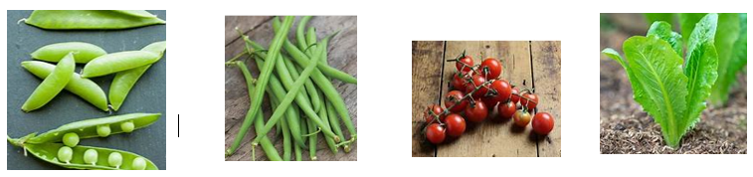

Starting off, was a little struggle, trying achieve the correct structure of the ‘pots’ by using cups, beakers and jars. However, with some perseverance, the Warriors succeeded! They folded newspaper and wrapped it around the jars/pots and finished off by folding the bits of paper at the bottom so that it made a base.
If you fancy having a go at making these at home follow the link below for short and simple tutorial.
How to make Newspaper Plant Pots - Easy Paper Seedling Pots in Minutes - only 2 minutes! - YouTube

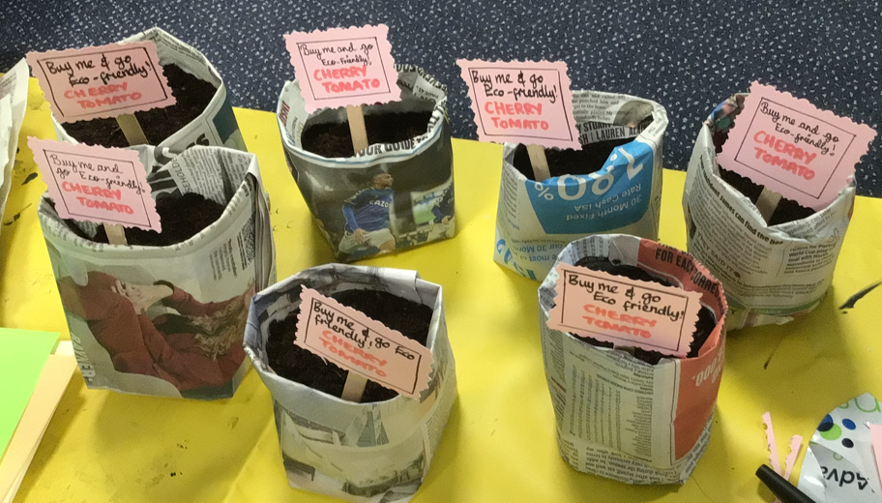
The Eco Warriors are excited to share their wonderful Eco pots at the upcoming school fair on 25th May 2022. They are completely sustainable! So keep an eye out at the fair and try to get your hands these pretty pots!

Great Big School Clean competition winner!
We are pleased to announce the winner for the ‘Big Bag Challenge’…#drumroll# SARAH ADEN in 3MM!
As part of the Great Big School Clean (Keep Britain Tidy) Sarah collected litter from her local area and even got her family involved! A great effort and commitment-well done Sarah and family. Keep up the good work and spread the ‘litter-locking’.
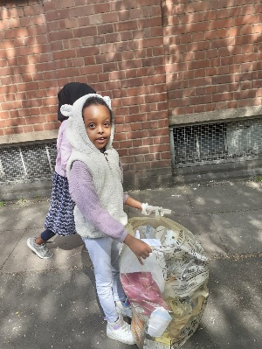
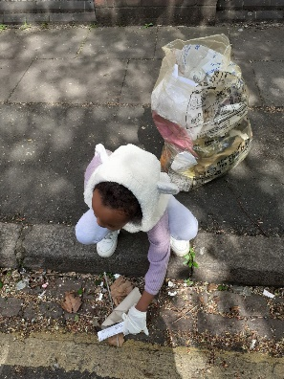
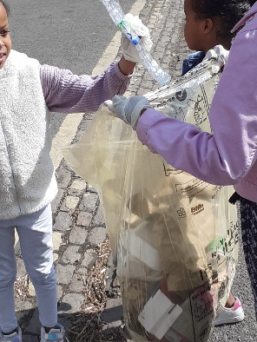
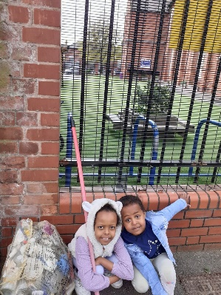
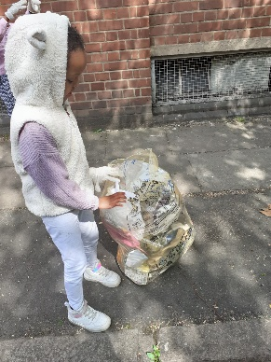
The Eco-Police will be doing their daily rounds to monitor energy use in your classroom so remember to switch off any energy that is not being used during the day.
Remember, there will be the lunchtime litter monitors-Litter Lockers who we can all support by locking up any litters we see on the playground and around the school straight into the bins!

