Uplands Junior L.E.A.D. Academy – Early Help Offer Updated August 2026 by LC
What is Early Help?
At Uplands Junior L.E.A.D. Academy, we understand that children and young people can experience a range of difficulties at any time in their life. To support and advise you at such times, we have an Early Help Offer, designed around the Leicester Early Help Assessment Model. This is a responsive, flexible and focussed model based on the three key aims: support, strengthen and thrive. The goal is to ensure children and young people are safeguarded, family outcomes are improved and the child’s health and wellbeing is promoted.
Leicester’s Early Help Partnership believes that children and young people’s needs are best met when addressed in the context of the whole family, with agreement, as part of a holistic ‘team around the family’ response. High quality services, appropriate to the family’s needs and views/lived experiences, are a right and where possible children and young people should be supported in their local communities in universal settings, avoiding the need for specialist or statutory involvement. Services providing early help should work collaboratively and share information appropriately in order to improve services to reduce the risks to children.
What support do we offer here at Uplands Junior L.E.A.D. Academy?
Our Early Help/Safeguarding Team here at Uplands Junior L.E.A.D. Academy is made up of the following people:
- Mrs L. Carlisle: Headteacher and Designated Safeguarding Lead.
- Mr L Buckley: Deputy Headteacher, and Deputy Designated Safeguarding Lead
- Mr J Deacon: Assistant Principal and Deputy Designated Safeguarding Lead
- Mrs M Shaukat: SENCO and Deputy Designated Safeguarding Lead
- Mrs S Yusuf: Pupil and Parent Support and Deputy Designated Safeguarding Lead
- Mr I Walker: Site Supervisor and Deputy Designated Safeguarding Lead
These staff have had additional training in safeguarding and supporting children and families. We can offer advise on a range of concerns or signpost parents/carers to other sources of information, help and support. If you need to contact any of the team, please contact our school office to arrange a meeting.
What sort of concerns might parents/carers share with our team?
A wide range of issues can be discussed such as behaviour management, financial worries and debts, domestic abuse, housing concerns, mobility difficulties, parents/carers in prison, bereavement and loss, bullying – in fact any concerns which you are worried might be having a negative impact on your children/children in your care.
What might we offer in response to our concerns?
We have skilled practitioners and bespoke interventions to support some pupils or groups of pupils, interventions such as Drawing and Talking therapy, ELSA led by Mrs Yusuf. In addition, many staff have received training on Attachment Disorder and Bereavement, within which many trauma-informed practices were explored. All of the above will assist us in providing support for your child/child in your care should they be struggling with social, emotional or mental health difficulties.
For attendance concerns, support will be offered through school and, if required, the Educational Welfare Officer will be brought in for further help.
If your child/child in your care’s needs cannot be met through school level intervention, we have the capacity to refer or signpost to external agencies who might be more suited to support at that time. To do this, a referral to Early Help Support may need to be made, with your permission.

How might the support be managed?
There are a range of ways of delivering support. Informal pastoral meetings with a record of conversation might be all that is required. Individual plans and risk assessments can be used to support individual pupils where necessary. The ‘9 step early help process’ from Leicester’s Early Help is followed:
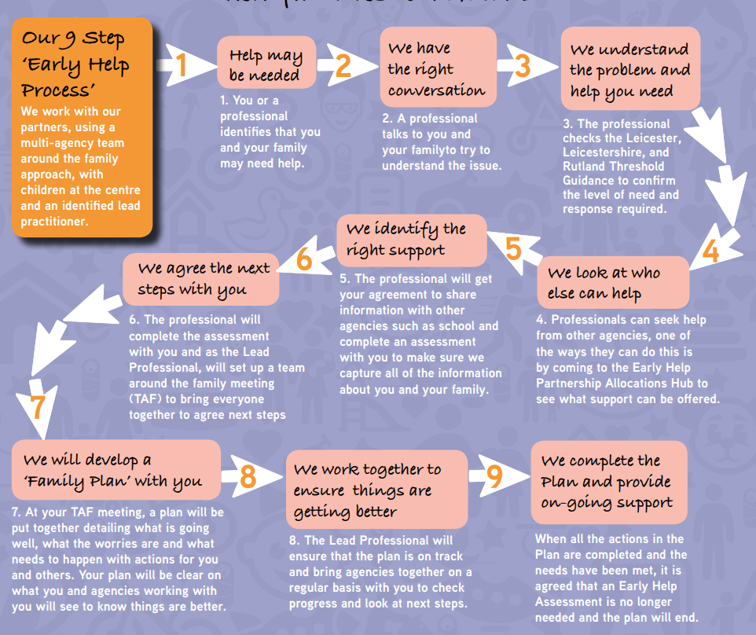
How will safeguarding procedures be effective in supporting families?
Uplands Junior L.E.A.D. Academy has Mrs L Carlisle (Designated Safeguarding Lead) and Mr Buckley, Mr Deacon, Mrs Shaukat, Mr Walker and Mrs Yusuf (Deputy Designated Safeguarding Leads) who are all trained by Leicester Safeguarding Children Partnership Board within Leicester City’s Local Authority. All staff are trained to identify and report safeguarding concerns and training is revisited and refreshed regularly, creating a whole school safeguarding ethos placing the children at the heart. Where concerns are raised, the school will follow the reporting procedures within our Safeguarding and Child Protection Policy.
The team will work with families and all relevant agencies to reduce and remove identified risks to children. Support will be given to families by these relevant agencies, including school.
How will our pupils learn to keep themselves safe?
Curriculum provision and additional work from outside agencies, including the NSPCC and the police, support our children in learning how to keep themselves safe. Children are also made aware of the role of the Early Help/Safeguarding Team in supporting them and many access the team independently. Our Pupil and Parent Support, Mrs Yusuf and often another member of the team are present each morning to meet and greet children and their families on our school playground. Posters are displayed around school and links to signposted agencies are available on our school website and on the safeguarding board by the school reception. Our website also has the ‘Report a Concern’ function where children can report a concern they may have at any time and it will be sent to Designated Safeguarding Leads.
Who might the school refer to?
The Early Help Team
Children and Young People’s Services
School Nursing Team
Speech and Language Therapist
Educational Psychologist
Education Welfare Officer
Bodie Hodges Foundation
The Laura Centre
Barnardo’s – Young Carers
SENDIASS

Signposting – agencies the school might suggest as sources of further support

Citizen’s Advice Bureau
GP
Occupational Therapist
Community Paediatrician
The Early Help Team
Healthy Together
The Freedom Project
Housing Associations
Food bank
SENDIASS
Children and Families Centre
Children and Adolescent Mental Health Service

When should I contact the Early Help/Safeguarding Team?

Contact us when you have a concern which is affecting your child(ren)/child(ren) in your care. We will always try and see you quickly or to give you a call to arrange a meeting to discuss any concerns with you.

