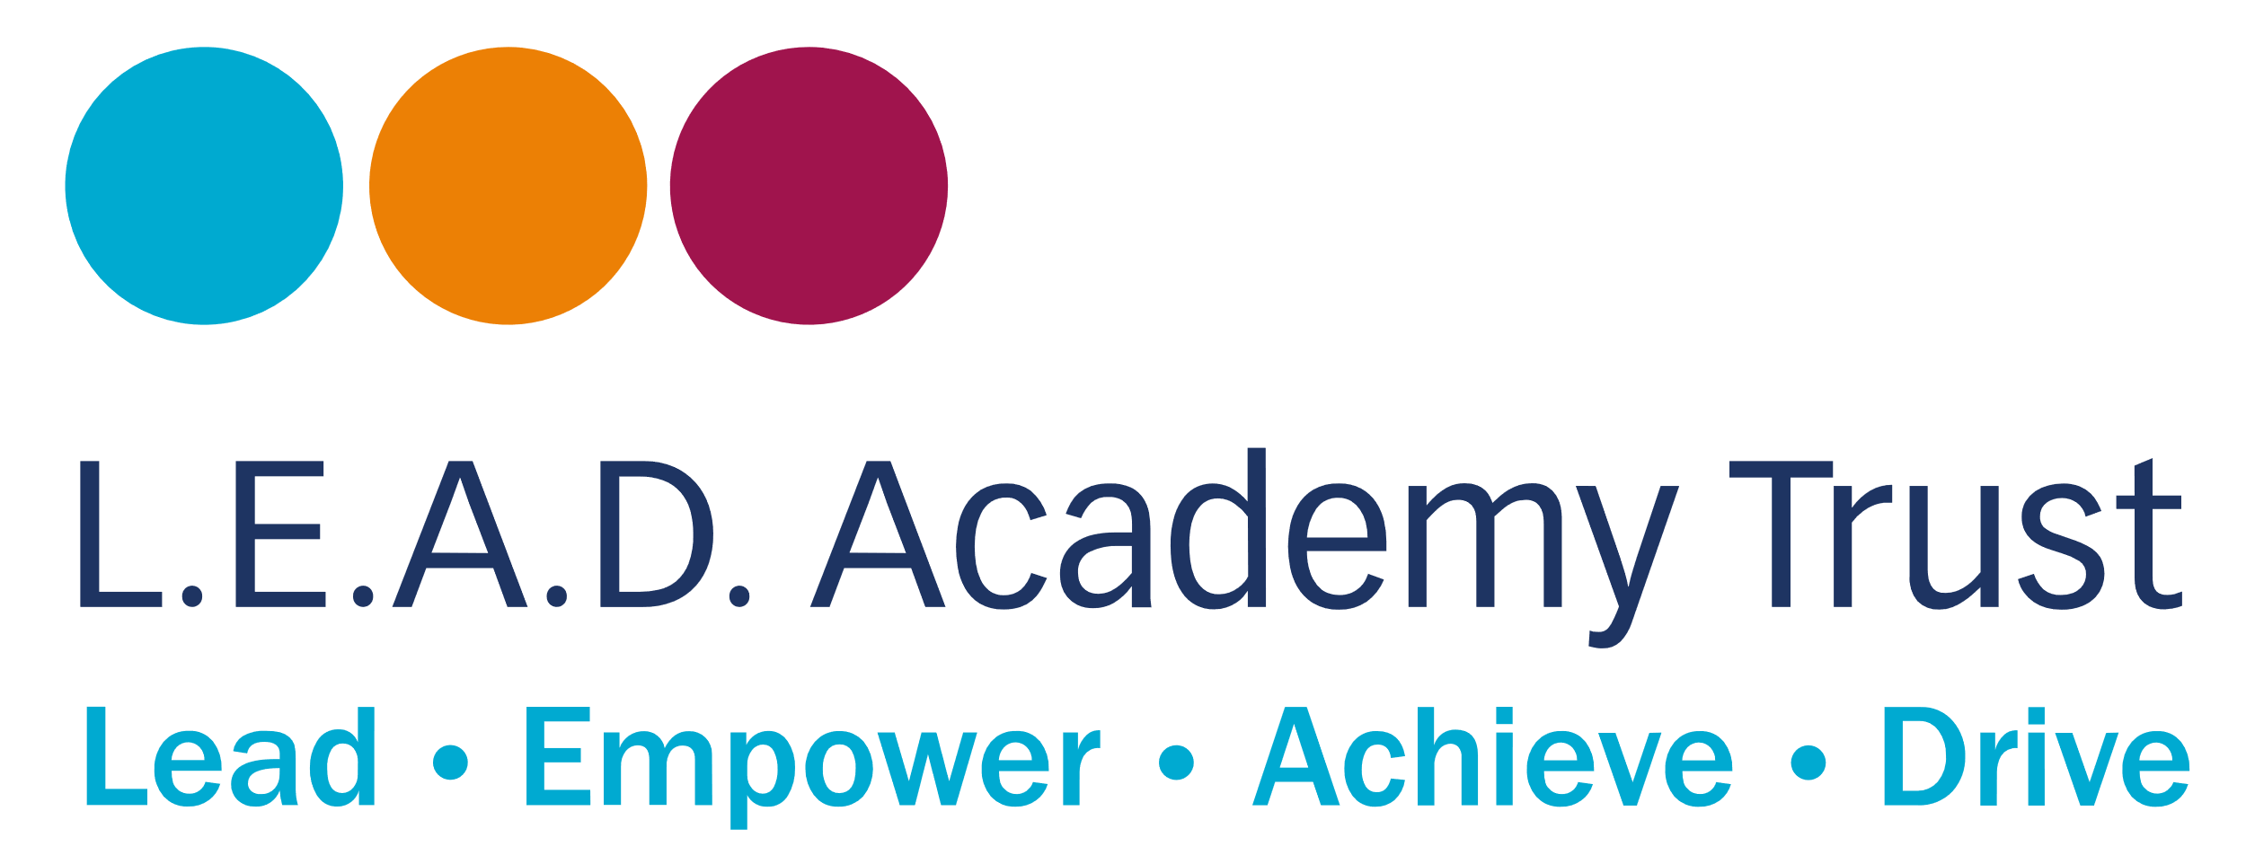

Uplands Junior L.E.A.D. Academy
Equality Information and Objectives

Policy/Procedure management log
Document name | Equality Policy
Trust approval | January 2026
Date approved by AGB | 26th March 2026
Date of review | January 2027

Aims

Our academy aims to meet its obligations under the Public Sector Equality Duty (PSED) by having due regard to the need to:
- Eliminate discrimination and other conduct that is prohibited by the Equality Act 2010
- Advance equality of opportunity between people who share a protected characteristic and people who do not share it
- Foster good relations across all characteristics – between people who share a protected characteristic and people who do not share it

Legislation and guidance

This document meets the requirements under the following legislation:
- The Equality Act 2010, which introduced the Public Sector Equality Duty and protects people from discrimination
- The Equality Act 2010, with amendments, due to the Worker Protection Act 2024
- The Equality Act 2010 (Specific Duties) Regulations 2011, which require schools to publish information to demonstrate how they are complying with the Public Sector Equality Duty and to publish equality objectives

This document is also based on Department for Education (DfE) guidance: The Equality Act 2010 and schools, and complies with our funding agreement and articles of association.

Roles and responsibilities

The Role of Trustees

Trustees are responsible for ensuring that the Trust and its academies comply with the Public Sector Equality Duty and adopt the overarching Trust Equalities Policy. Through the Scheme of Delegation, the Trust Board assigns local adaptation of the policy for each academy.

The role of Academy Governing Bodies
Academy Governing Bodies (AGBs) are the “responsible body” for ensuring that the academy meets the requirements of equality legislation. Essentially this means they should:
- Ensure the academy takes all reasonable steps to ensure that its employees do not carry out unlawful discriminatory actions or behaviour.
- Support and guide the academy to have “due regard” for equality in all its functions.
- Ensure the academy complies with the Equality Duty and meets the two “specific duties” for academies.
- Ensure that the equality information and objectives as set out in this statement are published and communicated throughout the academy, including to staff, pupils and parents
- Ensure that the published equality information is updated at least every year, and that the objectives are reviewed and updated at least every 4 years
- Delegate responsibility for monitoring the achievement of the objectives on to the Headteacher.

The Role of the Headteacher
- Ensure that the L.E.A.D. Academy Trust policy is adopted and implemented
- Promote knowledge and understanding of the equality objectives among staff and pupils
- Monitor success in achieving the objectives and report back to governors

All academy staff are expected to have regard to this document and to work to achieve the objectives.

Eliminating discrimination

The academy is aware of its obligations under the Equality Act 2010 and complies with non-discrimination provisions.
Where relevant, our policies include reference to the importance of avoiding discrimination and other prohibited conduct.
Staff and governors are regularly reminded of their responsibilities under the Equality Act – for example, during meetings. Where this has been discussed during a meeting, it is recorded in the meeting minutes.
New staff receive training on the Equality Act as part of their induction, and all staff receive training via the National College modules.
The academy has a designated member of staff for monitoring equality issues, and an equality link governor. They regularly liaise regarding any issues and make senior leaders and governors aware of these as appropriate.

Advancing equality of opportunity

As set out in the DfE guidance on the Equality Act, the academy aims to advance equality of opportunity by:
- Removing or minimising disadvantages suffered by people that are connected to a particular characteristic they have (e.g. pupils with disabilities, or gay pupils who are being subjected to homophobic bullying)
- Taking steps to meet the particular needs of people who have a particular characteristic (e.g. enabling Muslim pupils to pray at prescribed times)
- Encouraging people who have a particular characteristic to participate fully in any activities (e.g. encouraging all pupils to be involved in the full range of academy societies)

In fulfilling this aspect of the duty, the academy will:
- Publish attainment data each academic year
- Analyse the above data to determine strengths and areas for improvement, implement actions in response and publish this information
- Make evidence available identifying improvements for specific groups (e.g. declines in incidents of homophobic or transphobic bullying)
- Publish further data about any issues associated with particular protected characteristics, identifying any issues which could affect our own pupils

Fostering good relations

The academy aims to foster good relations between those who share a protected characteristic and those who do not share it by:
- Promoting tolerance, friendship and understanding of a range of religions and cultures through different aspects of our curriculum. This includes teaching in RE, citizenship and personal, social, health and economic (PSHE) education, but also activities in other curriculum areas. For example, as part of teaching and learning in English/reading, pupils will be introduced to literature from a range of cultures
- Holding assemblies dealing with relevant issues. Pupils will be encouraged to take a lead in such assemblies, and we will also invite external speakers to contribute
- Working with our local community. This includes inviting leaders of local faith groups to speak at assemblies, and organising academy trips and activities based around the local community
- Encouraging and implementing initiatives to deal with tensions between different groups of pupils within the academy. For example, our academy council has representatives from different year groups and is made up of pupils from a range of backgrounds. All pupils are encouraged to participate in the academy’s activities, such as sports clubs. We also work with parents to promote knowledge and understanding different cultures
- Developing links with people and groups who have specialist knowledge about particular characteristics, which helps inform and develop our approach.

Equality considerations in decision-making

The academy ensures it has due regard to equality considerations whenever significant decisions are made.
The academy always considers the impact of significant decisions on particular groups. For example, when an academy trip or activity is being planned, the academy considers whether the trip:
- Cuts across any religious holidays
- Is accessible to pupils with disabilities
- Has equivalent facilities for boys and girls
The academy keeps a written record (known as an Equality Impact Assessment) to show we have actively considered our equality duties and asked ourselves relevant questions. This is recorded at the same time as the risk assessment when planning academy trips and activities. The record is completed by the members of staff organising the activity and is stored electronically with the completed risk assessment.

Equality objectives

The academy aims to set three objectives:

- One focused on pupil outcomes and relating to an issue/characteristic affecting a disproportionately large share of our pupils compared to the national average; this will help to ensure our academy is able to take action which will have an impact on a significant scale.

- One objective focused on outcomes and relating to an issue/characteristic significantly affecting a small share of pupils compared to the national average. Research nationally suggests some of the largest and most stubborn ‘gaps’ in outcomes are in academies with very small numbers of children with that particular characteristic – such pupils should not be overlooked.

- One objective relating to actions with a wider scope/impact, perhaps in relation to curriculum content, enrichment activities, developing the ‘whole child’, whole school values and behaviours, work with parents/carers and the wider community or a workforce issue; this will ensure equality is not seen exclusively in relation to pupil outcome measures.

Requirement to publish information annually:

The academy will publish an annual update on the website. This update will include:

  - Pupil information: academy level data about the composition of the pupil population and their outcomes, in relation to gender, Special Educational Needs (SEN) and disability, race/ethnicity and those with English as an Additional Language (EAL), children who are/have been Looked After (CLA) and pupils who are eligible for Free School Meals (FSM), or who more broadly qualify for the Pupil Premium.

Links with other policies

This document links to the following policies:
- Accessibility plan
- Supporting pupils with medical conditions
- Behaviour policy
- Code of Conduct

ACADEMY OBJECTIVES PLAN 2026 - 2029

Target | Actions | How will the impact of action be monitored?  Who is responsible | Timeframe | Impact – annual review  Review date:
1.Ensure that minority ethnic and faith groups feel secure and valued in our community so that diversity is celebrated and understood through rich learning opportunities. | - Stakeholder views survey  - Review of curriculum in relation to diversity  - Ensure that the reading spine encompasses a diverse range of authors and themes | Increasing engagement within the community  Increase in opportunities to celebrate diversity through the curriculum and noted in QA visits | Termly | Next steps (review date Sept 2026)
2.To ensure that the school promotes role models and heroes that young people positively identify with, who reflect and broaden the school’s diversity in terms of race, gender and disability etc. | - Broad range of books in library  - Visits out and visitors into school that inspire ambition.  - Diverse assemblies and special non curriculum days. | Representation is considered in all areas of school life.  Monitored by SLT | Termly | Next steps (review date Sept 2026)
3. To reduce inequality and improve life chances of pupils in the academy | - Develop effective provision that meets the needs of PPG students  - Review PPG pupils work termly to establish if needs are met. Pupil progress meetings.  - Review PPG funding to ensure that it is used to maximise opportunity and reduce disadvantage. | Key performance indicators reviewed termly (SLT)  Monitoring of progress of PPG pupils termly, identifying trends and next steps (SLT)  Track attendance in the academy of PPG pupils (Attendance team) | Termly | Progress and attainment gaps minimal.  Child’s voice  Pupil Premium Strategy reflects the changing needs of the children and is impactful.
4.To ensure enrichment and out of school activities are made accessible to all pupils, including those with disabilities and special educational needs, to ensure equitable accessibility and the best possible educational outcome | - Trips and opportunities planned are fully inclusive of all children and staff.  - Before and after school provision open to all equally. | Mrs Wood tracks club participation and this is documented on the PE and Sport report.  Mrs Wood and Mrs Carlisle are responsible for trips and visits. | Termly | Next steps (review date Sept 2026)
5.To tighten our approach to the identification and support of pupils with SEND to ensure there is no discrimination of those children with protected characteristic | - Use of vulnerability Index to identify children with multiple vulnerabilities | Accurate admission and assessment information.  SENCO leads this.  Children are staff receive regular info on Protected Characteristcs. | Termly | Next steps (review date Sept 2026)

