Year 4 Anglo-Saxon Day
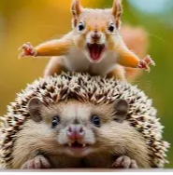
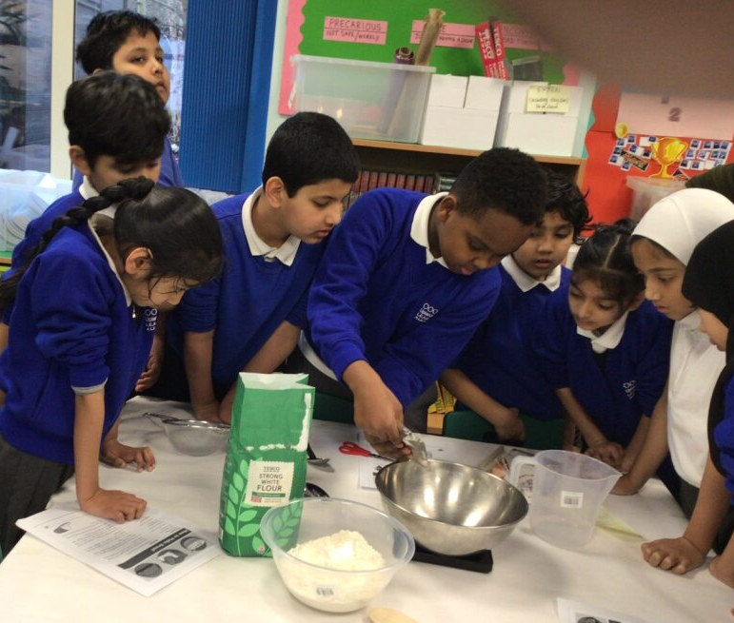
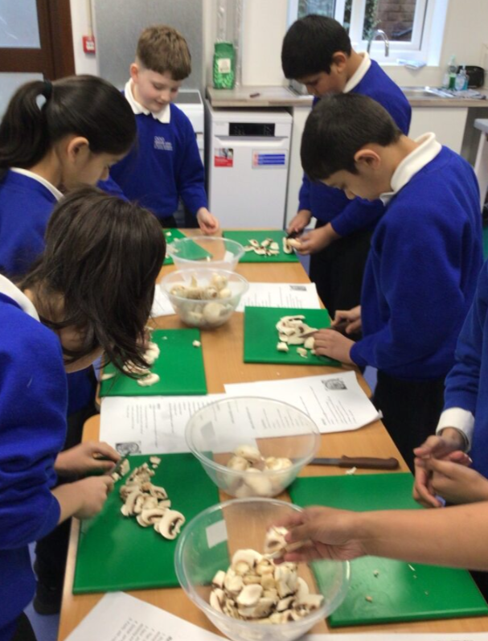
This term, Year 4 have been investigating their history enquiry question: Why is England not part of Rome today? Through our study of the Anglo-Saxons, pupils have been exploring key aspects of Anglo-Saxon life and discovering the lasting influence this period has had on Britain. So far, our learning has covered Anglo-Saxon society, methods of communication and language, as well as the important role of women during this time.
Food shortages were a real problem for the Anglo-Saxons. They often ate squirrels, hedgehogs, small birds, cats and dogs during times of famine.
On Monday, Year 4 had an amazing time travelling back to the Anglo-Saxon era! We started the day by making our very own bread—just like Anglo-Saxon slaves would have done (although we did cheat a little by buying the ingredients instead of growing our own wheat!).
The children loved following the recipe, mixing the ingredients, and kneading the dough. Their favourite part was shaping their rolls and buns after the dough had proofed. We definitely have some talented bakers in Year 4!

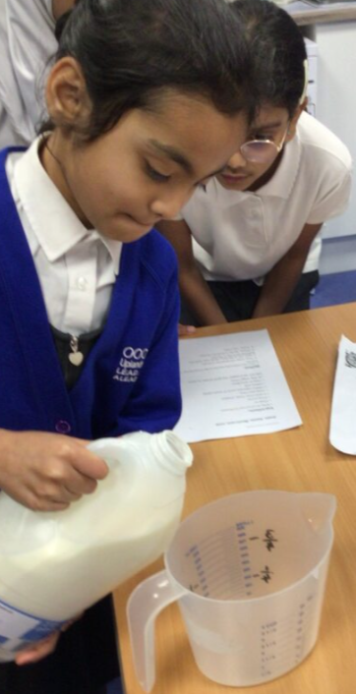
Each class had a group of children who followed a real Anglo-Saxon recipe to make mushroom soup! Our super chefs chopped onions and mushrooms and added just the right amount of seasoning to create a simple but delicious soup. It was enjoyed by parents and children alike!
If you’d like to try making Anglo-Saxon mushroom soup at home, take a look at the attached recipe—you might want to buy your ingredients from the shop to make things a little easier than the Anglo-Saxons did!

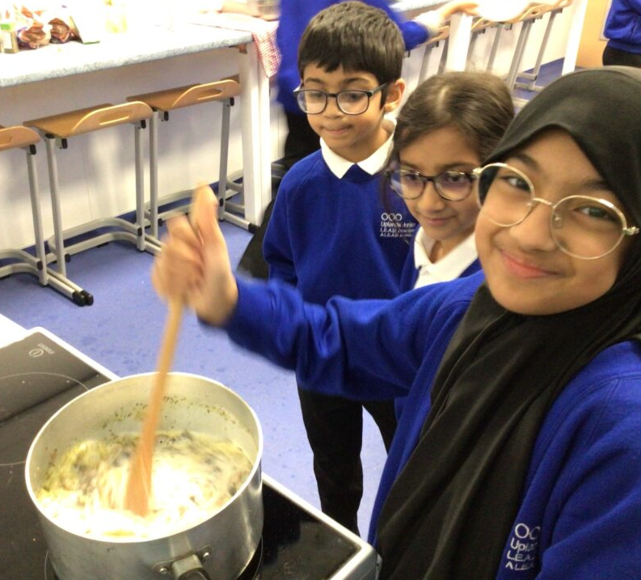
Fun (or scary) facts:
Parents were allowed to sell any children under the age of seven! They often did this during famines so that they would have fewer mouths to feed.

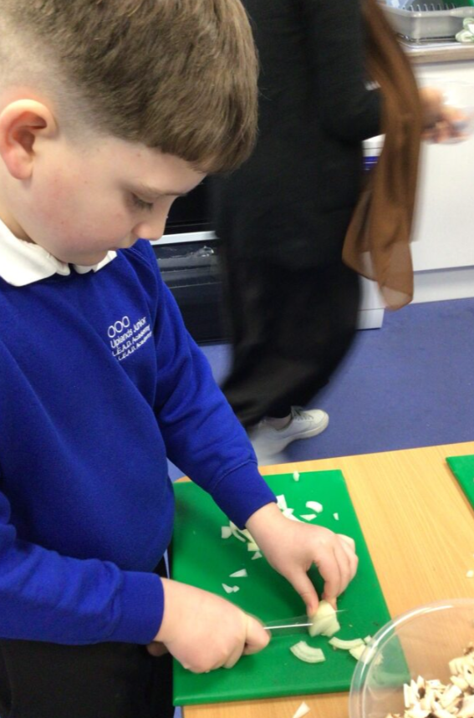

Throughout the day, Year 4 explored different historical disciplinary skills such as ‘interpreting history’ and ‘continuity and change’. One of the activities that the pupils took part in was to observe an Anglo Saxon artefact and note what they could decipher about the item. They then used these observations to attempt to use it as evidence in explaining how the Anglo Saxons lived.

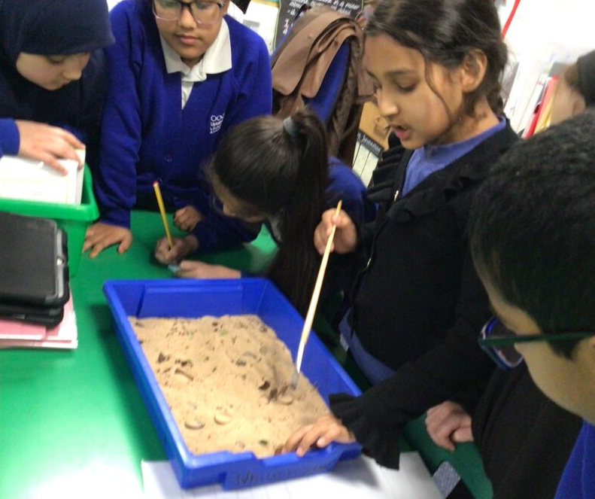

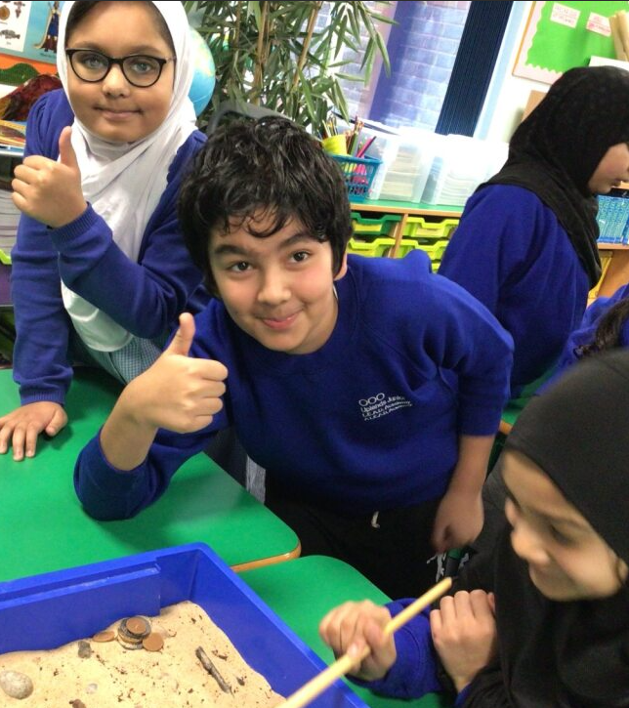
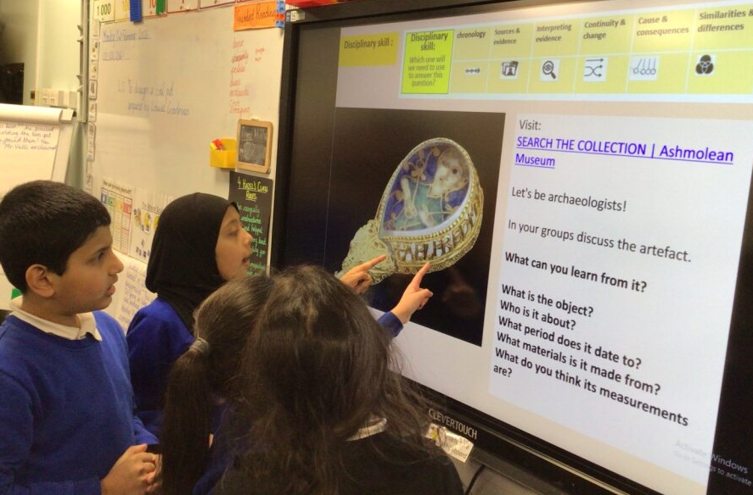

Year 4 also learnt about Kennings and had the opportunity to write their own Kenning poems. Kennings s are phrases of two words that replace a noun in poetry, often found in Anglo-Saxon and Norse poems. Kennings can be a type of poem and like a riddle. Kennings are commonly used in poetry to describe something without saying what it is.
Have a go at reading one which was written by Ibrahim Boularas in 4 Hazel.

Can you guess what is being described?

Sky flyer,
Fire breather,
Massive scales,
Sharp teeth,
Loud roarer,
Adrenaline maker

Answer: Dragon

To finish off the day, we gathered around the fire to enjoy the delicious bread we had made—just like people did in Anglo-Saxon times. To make the experience feel even more real, the children foraged for wood in the nature area and even had a go at sawing some of the larger pieces to help build the fire!
Everyone had great fun warming their bread over the flames and eating it with some tasty vegetable soup.
Did you know that Anglo-Saxons had open fires both inside their homes and in the middle of their villages? They used them for warmth and for drying out clay utensils. It was a brilliant way for Year 4 to step into the past!

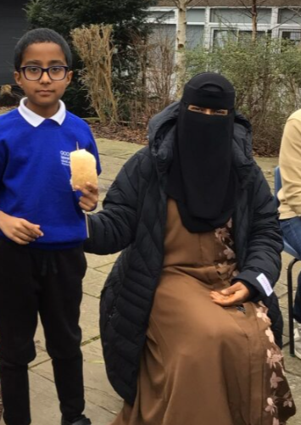
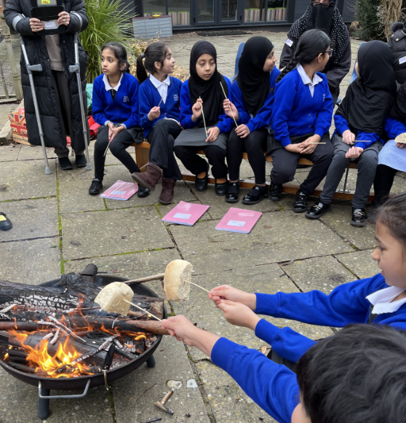

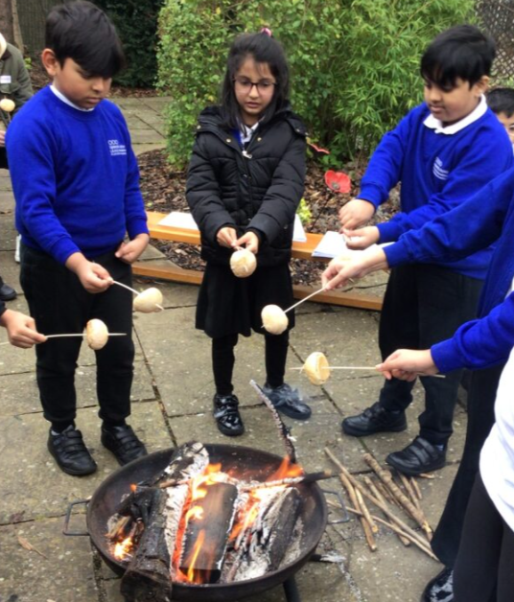

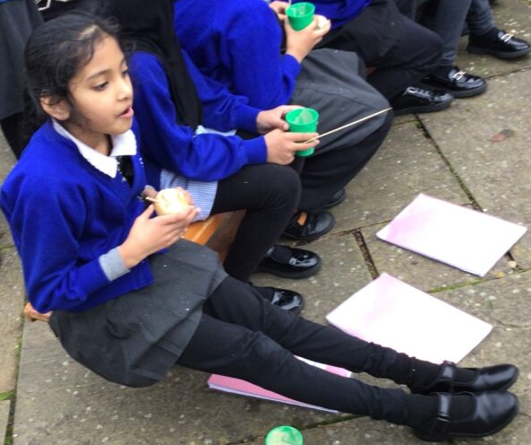
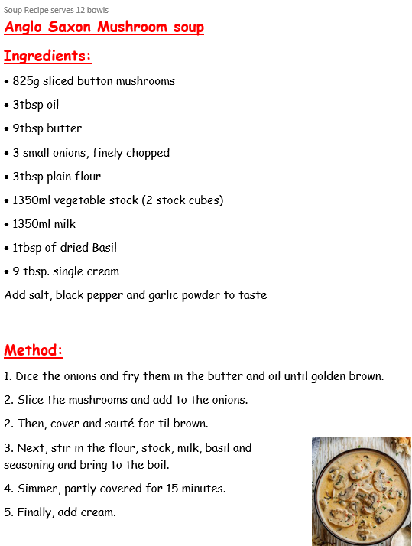
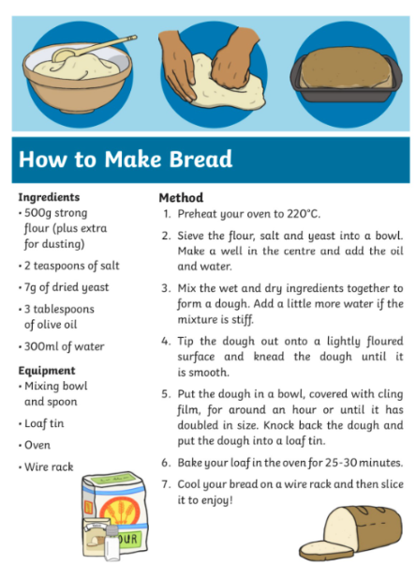
Try these recipes at home!
